实验四 Mindspore实现手写字体识别
姓名 章栋杰
学号 226001033
学院 阳明学院
专业班级 计算机2班
一、实验目的
加深对神经网络原理的理解
熟悉Minspore平台
掌握训练过程

二、实验环境
1. Windows
2. Anaconda虚拟环境—— Python3.7.5
3.在上述python里安装好mindspore框架
4. (建议)在集成开发环境(IDE)—— PyCharm上编写代码

三、实验内容
1. 使用MindSpore框架以及所给文档里的代码完成Mnist手写数据集的识别任务：

1.1 训练模型；

1.2 单个batch的测试集可视化，(batchsize = 8)；

1.3 利用训练好的模型对单个batchsize进行预测，并给出它们的预测结果

2. 尝试通过调整模型结构 or 参数 or 超参数 or 权重初始化方式使得测试集准确率达到Baseline，即准确率需要≥97%。

四、实验步骤：

- 下载压缩包里的数据集以及数据集加载文件夹放置目录如下：
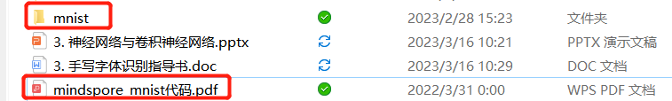

- 安装Anaconda软件并使用conda命令创建python3.7.5环境；

- 在上述环境中安装好相关的依赖库，特别是mindspore库；

- 参照代码pdf文件和ppt里的步骤编写mnist手写数据集代码，完成训练与预测，在word中粘贴可视化结果图；

- 尝试通过调整模型结构 or 参数 or 超参数 or 权重初始化方式（训练epoch最大不能超过30）使得测试集准确率超过Baseline，最好准确率需要≥97%。粘贴测试准确率截图，如下图：
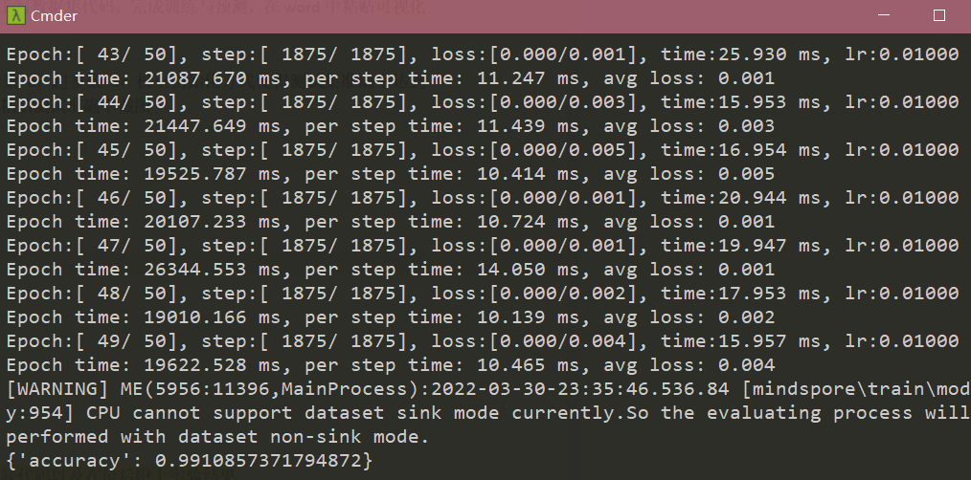

6. 用自己的话解释代码中主要函数的意义。（输入、输出以及做了什么工作，不必非常精确，体现自己的理解为主、不要单纯复制粘贴已有信息或网上资料）

- 代码提交

"""
-------导入依赖包-----
"""

# 注释——导入依赖包
# coding: utf-8
from mindvision.dataset import Mnist
import mindspore.nn as nn
from mindspore import Model
from mindspore.train.callback import ModelCheckpoint, CheckpointConfig
from mindvision.engine.callback import LossMonitor
from mindspore import load_checkpoint, load_param_into_net
import numpy as np
from mindspore import Tensor
import matplotlib.pyplot as plt
from mindspore.common.initializer import Normal
logging.basicConfig(level=logging.INFO, format='%(asctime)s - %(levelname)s - %(message)s')
logger = logging.getLogger(__name__)

context.set_context(mode=context.GRAPH_MODE, device_target="GPU", save_graphs=False)

summary_path = "runs/LeNet5"
num_classes = 10
batch_size = 8
save_checkpoint_path = "saved/"
save_model_name = "LeNet"

class LeNet5(nn.Cell):
def __init__(self, num_class=10, num_channel=1):
super(LeNet5, self).__init__()
self.conv1 = nn.Conv2d(num_channel, 6, 5, pad_mode='valid')
self.conv2 = nn.Conv2d(6, 16, 5, pad_mode='valid')
self.fc1 = nn.Dense(16 * 5 * 5, 120, weight_init=XavierUniform(), bias_init=XavierUniform())
self.fc2 = nn.Dense(120, 84, weight_init=XavierUniform(), bias_init=XavierUniform())
self.fc3 = nn.Dense(84, num_class, weight_init=XavierUniform(), bias_init=XavierUniform())
self.relu = nn.ReLU()
self.max_pool2d = nn.MaxPool2d(kernel_size=2, stride=2)
self.flatten = nn.Flatten()

def construct(self, x):
x = self.conv1(x)
x = self.relu(x)
x = self.max_pool2d(x)
x = self.conv2(x)
x = self.relu(x)
x = self.max_pool2d(x)
x = self.flatten(x)
x = self.fc1(x)
x = self.relu(x)
x = self.fc2(x)
x = self.relu(x)
x = self.fc3(x)
return x

def create_dataset(data_path, batch_size=32, repeat_size=1,
num_parallel_workers=1):
# define dataset
mnist_ds = MnistDataset(data_path)
# define map operations
trans = [
vision.Resize((32, 32)),
vision.HWC2CHW(),
vision.Normalize((0.1307,), (0.3081,)),
]
# apply map operations on images
mnist_ds = mnist_ds.map(operations=trans, input_columns="image", num_parallel_workers=num_parallel_workers)
# apply repeat operations
mnist_ds = mnist_ds.repeat(repeat_size)
# apply batch operations
mnist_ds = mnist_ds.batch(batch_size)
return mnist_ds

def train_net(data_path, epoch_size, repeat_size, batch_size, save_checkpoint_path,
save_model_name):
ds_train_path = os.path.join(data_path, "train")
mnist_ds = create_dataset(ds_train_path, batch_size=batch_size, repeat_size=repeat_size)
net = LeNet5(num_class=num_classes)
loss = nn.SoftmaxCrossEntropyWithLogits(sparse=True, reduction='mean')
opt = nn.Adam(params=net.trainable_params(), learning_rate=0.001)
model = Model(net, loss, opt, metrics={"Accuracy": Accuracy()})
time_cb = SummaryCollector(summary_dir=summary_path)
ckpt_config = CheckpointConfig(save_checkpoint_steps=1875, keep_checkpoint_max=10)
ckpt_cb = ModelCheckpoint(prefix="checkpoint_lenet", directory=save_checkpoint_path, config=ckpt_config)
loss_cb = LossMonitor()
callbacks = [time_cb, ckpt_cb, loss_cb]
model.train(epoch_size, mnist_ds, callbacks=callbacks)
save_checkpoint(net, os.path.join(save_checkpoint_path, save_model_name + ".ckpt"))

if __name__ == '__main__':
train_net(data_path="mnist", epoch_size=10, repeat_size=1, batch_size=32,
save_checkpoint_path=save_checkpoint_path, save_model_name=save_model_name)
"""
-------xxxx-----
"""

# 注释——xxxxx
xxxxxxx

- 测试集可视化
【图】
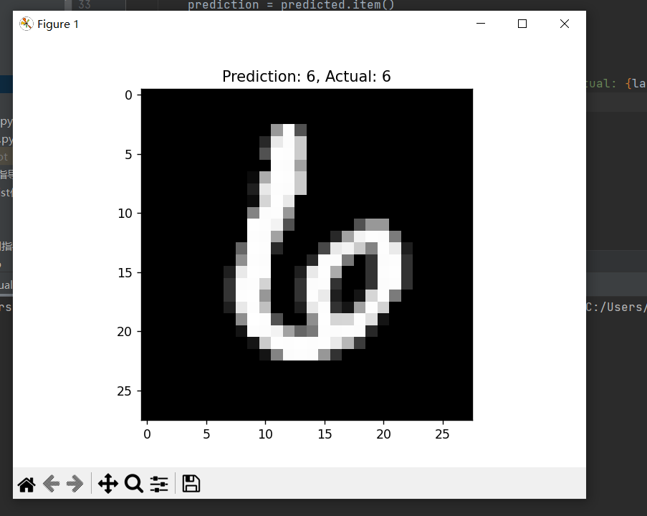
- 测试集准确率截图
【图】
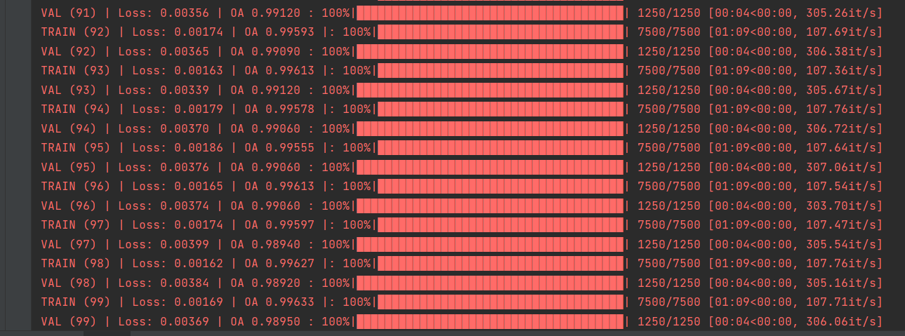
并简要描述下你是通过做了哪些操作让准确率上升的？
回答：
调整了学习率、Lenet模型架构、增加了数据量

